REACT BASIC

What is react?

* React is a JavaScript library for building user interfaces.
* React is used to build single page applications.
* React allows us to create reusable UI components.

Let’s start with react….

1. First download node.js
2. Then , Install create-react-app by running this command in your terminal:

C:\Users\Your Name>npm install -g create-react-app

1. Run this command to create a React application named myfirstreact:

C:\Users\Your Name>npx create-react-app myfirstreact

The create-react-app will set up everything you need to run a React application

**Now wait for 5 minutes**

We suggest that you begin by typing:

cd gulab

npm start

Happy hacking!

When you find these four line means, your app is created by node.js.

Now time to run our app, so for that just move in your folder by cd commond.

Then Run this command to run the React application myfirstreact:

C:\Users*Your Name*\myfirstreact>npm start

A new browser window will pop up with your newly created React App! If not, open your browser and type localhost:3000 in the address bar.

The result:

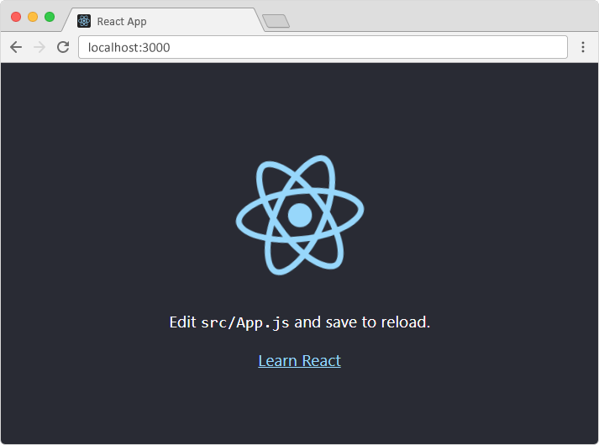

You can also see result in your mobile if your on same network .

We can mathematical calculation using { code}

We just have start writing code in app.js file

mport logo from './logo.svg';

import './App.css';

function App() {

  return (

    <h1>Hello World </h1>

  );

}

export default App;

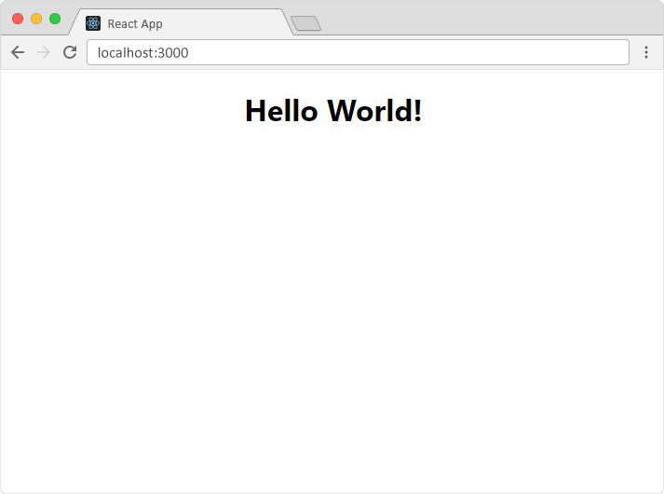

**Now if you want to write more than one line then you need to write all code in a div tag.**

import './App.css';

function App() {

   let a=20;

   let b=60;

  return (

    <div className="App">

      <p>Raju have {a} Bananas and  Shayam has {b} Apples</p>

      <h1> Total fruits are {a+b}</h1>

    </div>

  );

}

export default App;

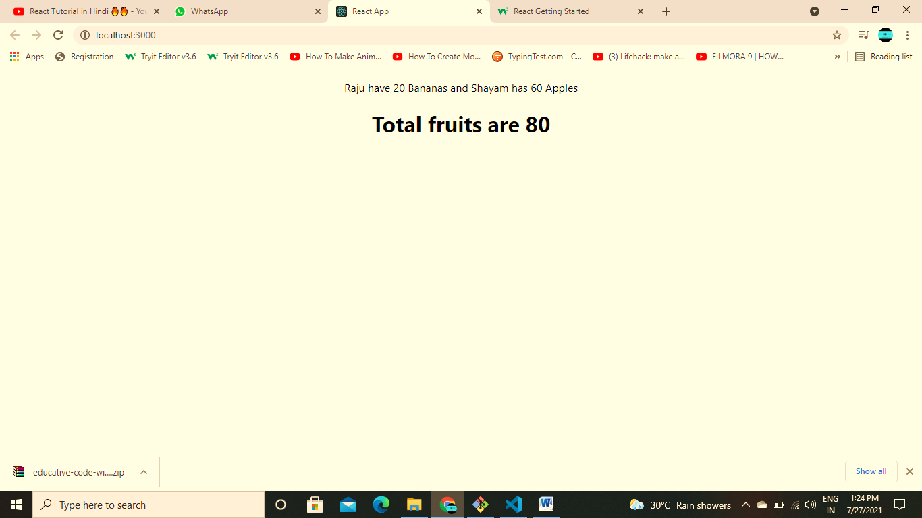

**You can use bootstrap if you want, for that you have to**

**Add In head tag of index.html file in public folder** <link href="https://cdn.jsdelivr.net/npm/bootstrap@5.0.2/dist/css/bootstrap.min.css" rel="stylesheet" integrity="sha384-EVSTQN3/azprG1Anm3QDgpJLIm9Nao0Yz1ztcQTwFspd3yD65VohhpuuCOmLASjC" crossorigin="anonymous">

**Add In body tag of index.html file in public folder**

<script src="https://cdn.jsdelivr.net/npm/bootstrap@5.0.2/dist/js/bootstrap.bundle.min.js" integrity="sha384-MrcW6ZMFYlzcLA8Nl+NtUVF0sA7MsXsP1UyJoMp4YLEuNSfAP+JcXn/tWtIaxVXM" crossorigin="anonymous"></script>

**Now You can write any code from bootstrape website.**

**Rather than writing many code in one page we can devide that in many components,**

**Create many pages and import these file in app.js file and use them.**

**Pops**

**Props basically us for passing data from parent to child .**

**We can recall props by passing it in function by just write (props).**

**Now we can call it by just writing props.data1 , props.data2, etc.**

**Propstypes**

Nav.propTypes={

  title : PropTypes.string

}

We use propTypes for defining types of our datas.

**defaultProps**

It is use do set default value of particular data,

Nav.defaultProps={

  title: "Algorithm Visiulaizer"

}

**Routing**

For routing first install routing dom by command

**npm install react-router-dom**

**Day -1 (Basic and Stylesheet and Props)**

import React from 'react'

import {View, Text,StyleSheet} from 'react-native'

const Dp= ({name,status} )=>{      *//making our components*

*// const{name ,status}=Props; //Destructuring Props*

return(

  <View style={styles.myview}>

    <Text> <b>Name</b> ={name}   <b>Status</b>= {status}</Text>

  </View>

)

}

const styles=StyleSheet.create({ //for style

  myview:{

    backgroundColor:"pink",

    padding:20,

    margin:10,

  }

})

function app(){ *//main function*

return(

  <View  >

  <Dp name="Durgesh" status="single" />

  <Dp name="Akash" status="Married" />

  </View>

  )

}

export default app  *//exporting function*

**Day -2 (Conditional JSX)**

import React from 'react'

import {View, Text,StyleSheet} from 'react-native'

function app(){

  let name ="Durgeshprajapati";

  let i=0;

  return (

    <View>

    {

      i==0 ? <Text>{name}</Text> :  <Text>Not exits</Text>

    }

    </View>

  )

}

export default app

**Day -3 (ArrayList)**

import React from 'react'

import {View, Text}  from 'react-native'

function  app(){

let myarray=[

  {id:"1",task:"eat"},

  {id:"2", task:"sleep"},

  {id:"3", task:"play"}

]

return (

  <View>

  { myarray.map(item=><Text>{item.task}</Text>)}

  </View>)

 }

export default app;

**Day-4 (use state ,Button)**

import React , {useState}from 'react'

import {Text, View , Stylesheet,Button} from 'react-native'

 function App(){

   const[a,seta]=useState("akash");

   return (

     <View>

     {

       a ?<Text>{a}</Text>:<Text>no name</Text>

     }

     <Button title="button" color="blueviolet" onPress={()=>{

       seta("")

     }}/>

     </View>

   )

 }

 export default App

**Day -5 (Attributes of Text )**

import React from 'react'

import { Text,View ,StyleSheet} from 'react-native'

import Constants from 'expo-constants'

function App(){

  return <Text numberOfLines={1} ellipsizeMode="middle"

  style={{paddingTop:Constants.statusBarHeight}}>

  jjsadasdhsddbhdl ddudikj bhjb uisdjksdboiu sdhiusddsfsnklnipojsddd

  </Text>

}

export default App;

To give margin from bar in android import ‘Constants ’ and use ‘paddingTop:Constants.statusBarHeight’ as attribute.

**Day-6 (Image,)**

import React from 'react'

import {Text , View , StyleSheet,Image,TouchableOpacity,TouchableHighlight} from 'react-native'

import Constants from 'expo-constants'

function App(){

  return (

    <View>

  <TouchableHighlight onPress={()=>{console.log("called")}}><Text style={{margin:20}}>Hello</Text></TouchableHighlight>

    <TouchableOpacity>

<Image source={require('./assets/snack-icon.png')} style={{ height:200,width:200}} />

    </TouchableOpacity>

<Image source={{uri:"https://i.pinimg.com/originals/58/bd/4f/58bd4fc9ebfccc1f2de419529bbf1a12.jpg"}}/>

    </View>

  )

}

export default App

**to import image use <Image > tag and give source it as attribute.**

**Use <TouchableOpecity> to give click effect.**

**And if you use <TouchHeighlight> Tag it will produce click effect with a blink.**

**Day -7 (FlatList)**

import React , {useState} from 'react'

import {View ,Text ,StyleSheet,FlatList}  from 'react-native'

function App(){

  const data=[

    {id:"1",title:"Act"},

    {id:"2",title:"Eat"},

    {id:"3",title:"Sleep"}

  ]

  return (

    <View>

      <FlatList data={data} renderItem={({item})=>{

        return <Text> {item.title}</Text>

      }}  horizontal={true}/>

    </View>

  )

}

export default App

**Day -8 (FlatList, Pull Object)**

import  React ,{useState} from 'react'

import { Text ,View ,Stylesheet ,FlatList} from 'react-native'

import Constants from 'expo-constants'

function App()

{

   const [data, addData]= useState[

     {id:"1",title:"1st"},

     {id:"2", title:"2nd"}

   ]

   const[loading,setLoading]=useState(false)

  return(

    <View  style={{paddingTop:Constants.statusBarHeight}}><Text>hello</Text>

    <FlatList data ={data} renderItem={({item})=>{

      return <Text> {item.title}</Text>

    }}

    onRefresh={()=>{

      setLoading(true)

      addData([...data,{id:"3",title:"3rd"}])

      setLoading(false)

    }}

      refreshing={loading}

      keyExtractor={(item)=>item.id}

    />

    </View>

  )

}

export default App

**Day -9 (ScrollView)**

import React from 'react'

import { Text ,View,StyleSheet,ScrollView} from 'react-native'

import Constants from 'expo-constants'

function App()

{

  return (

    <View style={{paddingTop:Constants.statusBarHeight}}>

    <ScrollView>

    <Text style={{backgroundColor:"pink",height:200,textAlign:"center",fontSize:22,marginBottom:20}}>Hello Akhilesh  Kaise ho app?

    </Text>

    <Text style={{backgroundColor:"pink",height:200,textAlign:"center",fontSize:22,marginBottom:20}}>Hello Akhilesh  Kaise ho app?

    </Text>

    <Text style={{backgroundColor:"pink",height:200,textAlign:"center",fontSize:22,marginBottom:20}}>Hello Akhilesh  Kaise ho app?

    </Text>

    <Text style={{backgroundColor:"pink",height:200,textAlign:"center",fontSize:22,marginBottom:20}}>Hello Akhilesh  Kaise ho app?

    </Text>

    <Text style={{backgroundColor:"pink",height:200,textAlign:"center",fontSize:22,marginBottom:20}}>Hello Akhilesh  Kaise ho app?

    </Text>

    </ScrollView>

    </View>

  )

}

export default App

**Day -10 (TextInput)**

import React, {useState} from 'react'

import {View , Text,StyleSheet,TextInput,Button} from 'react-native'

function App(){

const [Itext,SetItext]=useState(" ")

  return (

    <View>

    <Text> Input Give</Text>

    <TextInput  placeholder="Enter here" style={{borderWidth:1}}

    onChangeText={(text)=>{

      SetItext(text)

    }}

    />

    <Button title="Button " onPress={()=>{

      console.log(Itext)

    }}/>

    </View>

  )

}

export default App

**Day-11 (Love Checker App)**

import React ,{useState} from 'react'

import { View, Text ,StyleSheet,TextInput,ActivityIndicator,Button } from 'react-native'

import Constants from 'expo-constants'

function App()

{

const [Itext1,setItex1]= useState(" ")

const [Itext2,setItex2]= useState(" ")

const [loading,setloading]= useState(false)

const love=()=>{

  setloading(true)

  setTimeout(()=>{

    setloading(false),

    alert("Love Between "+ Itext1 +" and "+ Itext2+ " "+ Math.floor(Math.random()*100)+" %")

  },3000)

}

if(loading){

  return(

  <View style={{alignItems:"center"}}>

  <Text>Calculating......</Text>

   <ActivityIndicator size="large" />

  </View>

  )

}

  return (

    <View style={{paddingTop:Constants.statusBarHeight,alignItems:"center"}}>

    <Text>Enter Names HERE......</Text>

    <TextInput placeholder="first Name"  style={{borderWidth:2,padding:10,margin:10}}

    onChangeText={(text)=>{

      setItex1(text)

    }}

    />

    <TextInput placeholder="second name"  style={{borderWidth:2,padding:10,margin:10}}

    onChangeText={(text)=>{

      setItex2(text)

    }}

    />

    <Button title="Love Checker" onPress={()=>{

      setItex1(Itext1),

      setItex2(Itext2),

      love()

    }}/>

    </View>

  )

}

export default App

**Day 12(Modal)**

import React ,{useState} from 'react'

import {Text ,View, Stylesheets,Modal,Button} from 'react-native'

import Constants from 'expo-constants'

function App(){

  const [modal, setmodal]=useState(false)

  return (

    <View style={{paddingTop:Constants.statusBarHeight}}>

    <Text> Modal</Text>

    <Text>Screen 1</Text>

    <Modal animationType="slide" visible={modal} onRequestClose={()=>{setmodal(false)}}>

    <Text> Modal  Opened </Text>

    <Text>Screen 2</Text>

    </Modal>

    <Button title =" open modal" onPress={()=>{setmodal(true)}}/>

    </View>

  )

}

export default App

**Day 13 (FlexBox)**

import React from 'react'

import {Text , View , StyleSheet} from 'react-native'

import Constants from 'expo-constants'

const Box =()=>{

  return (<View style={styles.mybox}/>)

}

function App()

{

  return (

    <View  style={styles.container}>

    <Box />

    <Box/>

    <Box />

    <Box/>

    <Box />

    <Box/>

    <Box />

    <Box/>

    <Box />

    <Box/>

    <Box />

    <Box/>

    </View>

    )

}

const styles=StyleSheet.create({

  mybox:{height:"20%",

  backgroundColor:"blue",

  width:"30%",

  borderWidth:2},

container:{

  backgroundColor:"violet",

  flex:0.7,

  flexDirection:"row",

  justifyContent:"space-evenly",

  flexWrap:"wrap"

}

})

export default App

**Day 14 (Joke App)**

import React ,{useState,useEffect} from 'react'

import {Text ,View,Stylesheet,Button} from 'react-native'

function App(){

  const [joke,setjoke]=useState(" ")

const getJoke= async()=>{

  const res= await fetch("http://api.icndb.com/jokes/random")

  const result= await res.json()

  setjoke(result.value.joke)

}

useEffect(()=>{getJoke()},[])

return (

<View>

<Text style={{textAlign:"center",fontWeight:"Bold",fontSize:20}}>Joke App</Text>

<Button title ="Get Joke"

onPress={()=>getJoke()}

/>

{

  joke?<Text>{joke}</Text>:null

}

</View>

)

}

export default App

**Day 15(Export and Import)**

import React from 'react'

import {Text,View} from 'react-native'

import Mp from './components/Profile'

import {About as Ab} from './components/About'

function App()

{

  return (

    <View>

    <Text>Home Page </Text>

    <Mp/>

    <Ab/>

    </View>

  )

}

export default App